What is SonarQube?

---------------------------

It is a Qulity Management Tool

Release :

Community => Free Open Source

Enterprise => Paid

Devloped in Java

What is Quality?

-----------------------

Code Quality

Peer Code Review

Static code review

Test Quality

Test Reports

Code coverage reports

Why we need SonarQube?

---------------------------------------

Quality of the software is very important

-- managing quality reports and timeline growth in terns of quality

-- Team need common place where code analysis review can be done

-- What is the problem in code --> Why is this problem? -->Who has introduced? --> how to fix it?

-- 70 % of bugs are found due to bad code quality

SonarQube Architecture

------------------------------------

=> SonarQube Server

Rules

Dashboard

Database--> Embeded database , MySQL, Oracle, H2.....

=> Scanner -> It is jar file and it is an agent running in a place where source code exist

This can be executed through

++ commandline

++ Maven

++ Gradle

++ Jenkins

=> Source Code -> Program code

How it works ?

------------------------

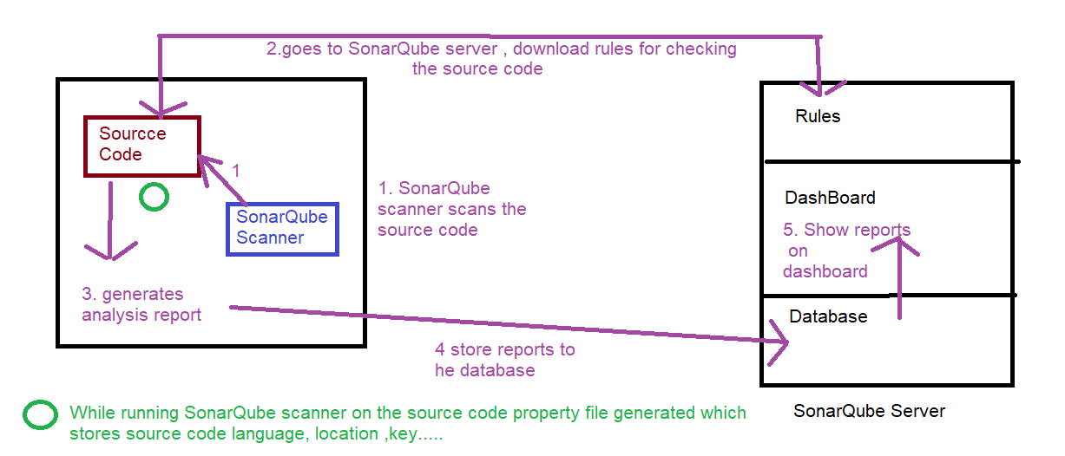

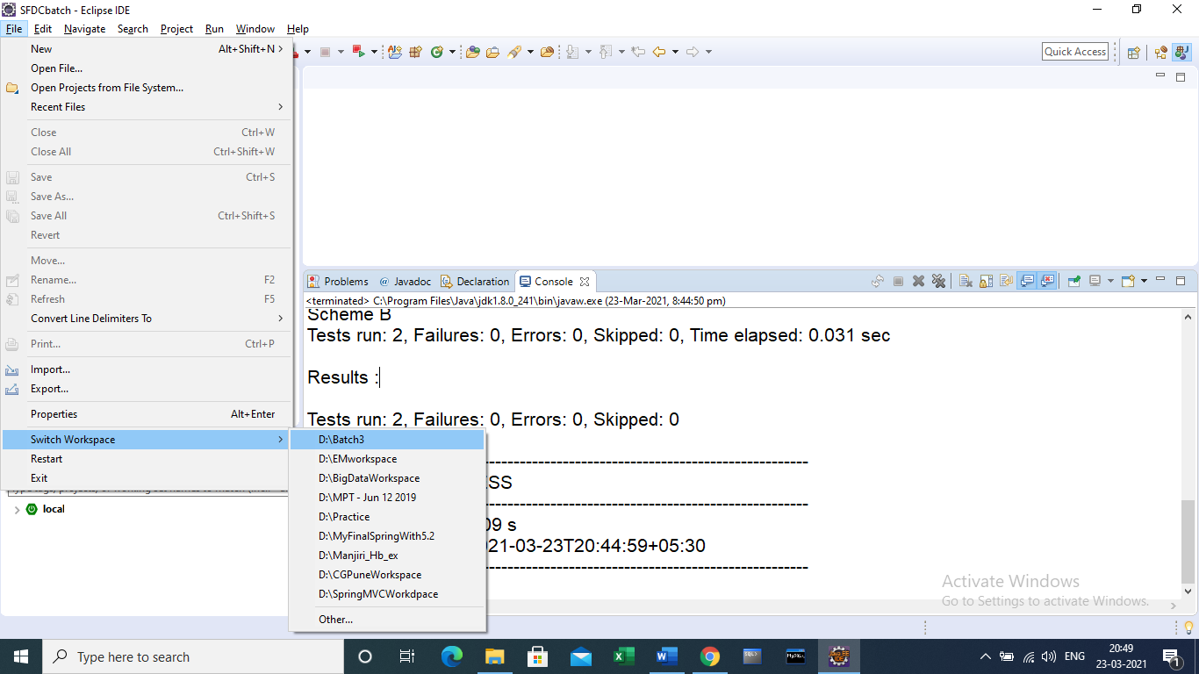

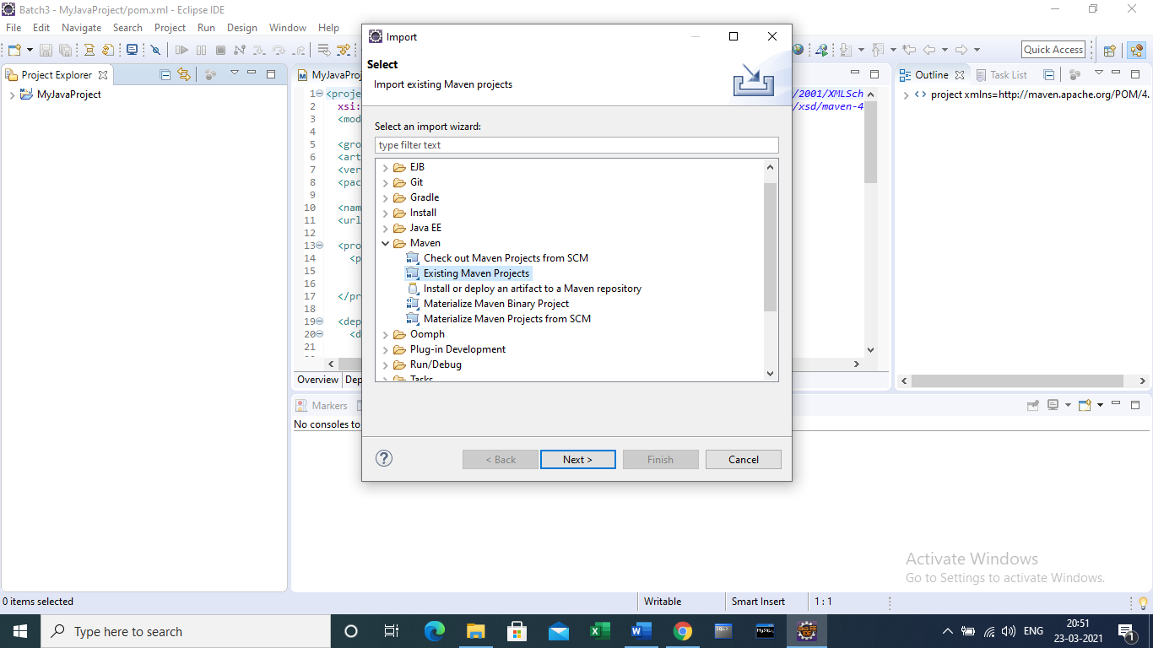

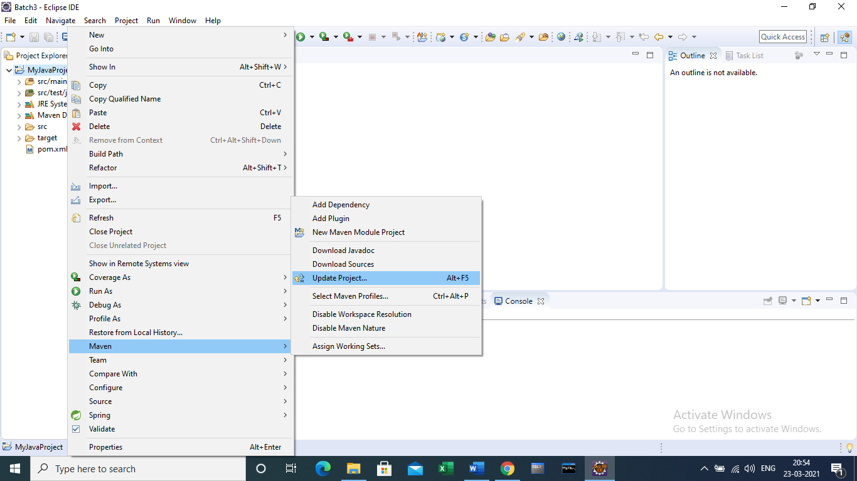

pom.xml

<project xmlns=*"http://maven.apache.org/POM/4.0.0"* xmlns:xsi=*"http://www.w3.org/2001/XMLSchema-instance"*

xsi:schemaLocation=*"http://maven.apache.org/POM/4.0.0 http://maven.apache.org/xsd/maven-4.0.0.xsd"*>

<modelVersion>4.0.0</modelVersion>

<groupId>com.cg</groupId>

<artifactId>MyJavaProject</artifactId>

<version>0.0.1-SNAPSHOT</version>

<packaging>jar</packaging>

<name>MyJavaProject</name>

<url>http://maven.apache.org</url>

<properties>

<project.build.sourceEncoding>UTF-8</project.build.sourceEncoding>

<maven.compiler.source>1.8</maven.compiler.source>

<maven.compiler.target>1.8</maven.compiler.target>

</properties>

<dependencies>

<dependency>

<groupId>junit</groupId>

<artifactId>junit</artifactId>

<version>4.3.1</version>

<scope>test</scope>

</dependency>

<!-- https://mvnrepository.com/artifact/org.sonarsource.scanner.maven/sonar-maven-plugin -->

<dependency>

<groupId>org.sonarsource.scanner.maven</groupId>

<artifactId>sonar-maven-plugin</artifactId>

<version>3.2</version>

</dependency>

</dependencies>

<profiles>

<profile>

<id>sonar</id>

<activation>

<activeByDefault>true</activeByDefault>

</activation>

<properties>

<!-- Optional URL to server. Default value is http://localhost:9000 -->

<sonar.host.url>

http://localhost:9000

</sonar.host.url>

</properties>

</profile>

</profiles>

<build>

<plugins>

<plugin>

<groupId>org.apache.maven.plugins</groupId>

<artifactId>maven-compiler-plugin</artifactId>

<version>3.6.0</version>

<configuration>

<source>1.8</source>

<target>1.8</target>

</configuration>

</plugin>

</plugins>

</build>

</project>

In above pom.xml following will download sonar scanner to analyse the project.

<groupId>org.sonarsource.scanner.maven</groupId>

<artifactId>sonar-maven-plugin</artifactId>

<version>3.2</version>

</dependency>

</dependencies>

SonaQube instruction

* Unzip Sonar Qube folder in c:
* Open command prompt and do following

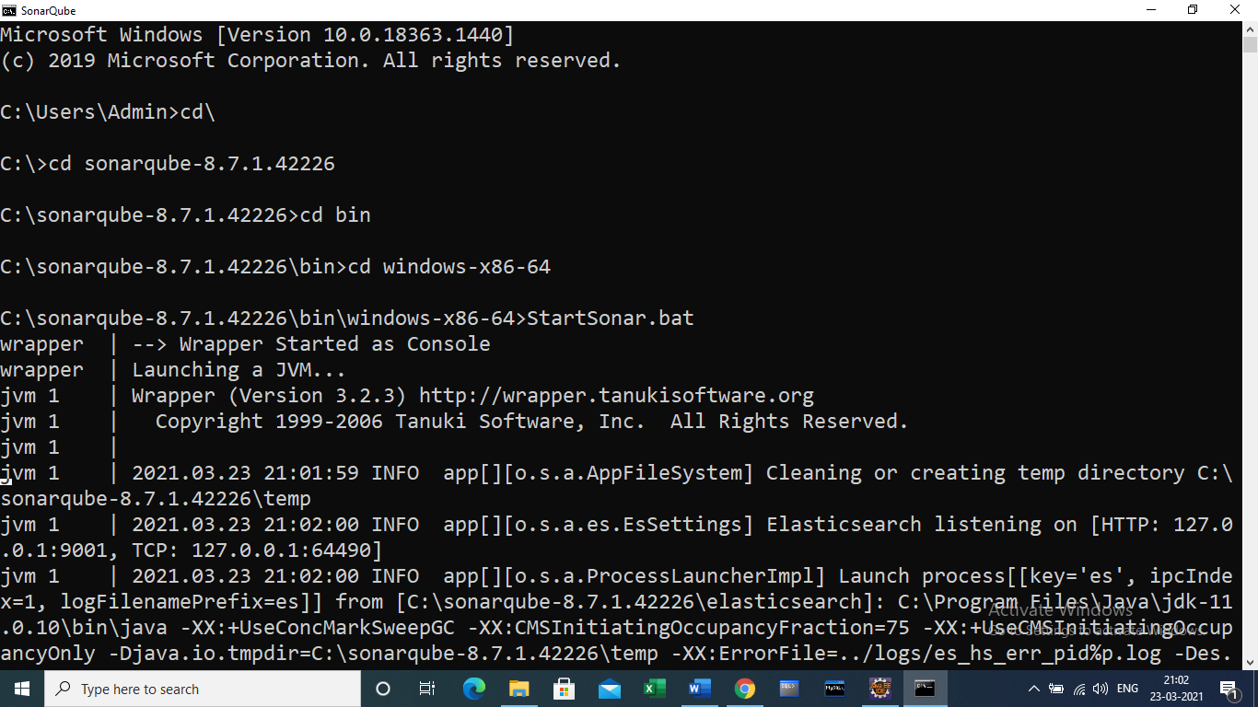

Server will start

* Open browser with url =><http://localhost:9000>

If you are having jdk other than 11 , Sonaqube server will not start.

Suppose you have installed jdk 15, install jdk 11 and

Run StartSonar.bat

Even if it does not run , make the following changes in wrapper.conf in conf folder

C:\sonarqube-8.7.1.42226\conf

Changes are

Instead of

wrapper.java.command=java

change it to

wrapper.java.command=C:/Program Files/Java/jdk-11.0.10/bin/java

Then run StartSonar.bat

Server will be up

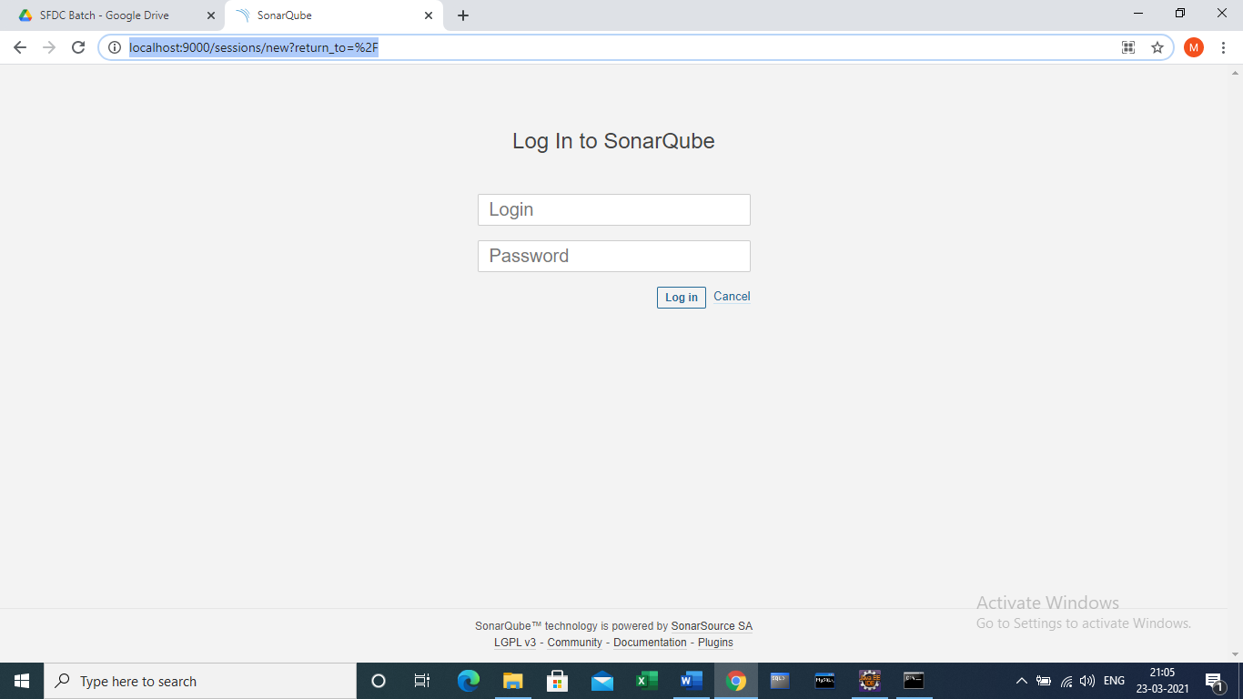

Type username=> admin , password => admin

Change the password

After login following screen will come

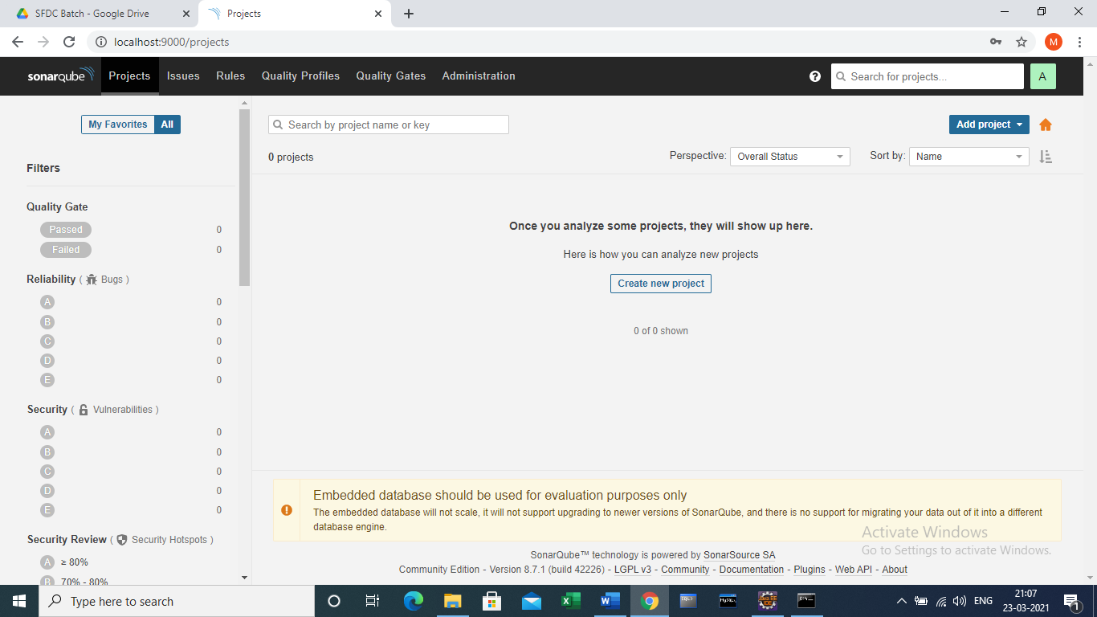

This is a SonarQube Server

Click on ‘Create New Project’

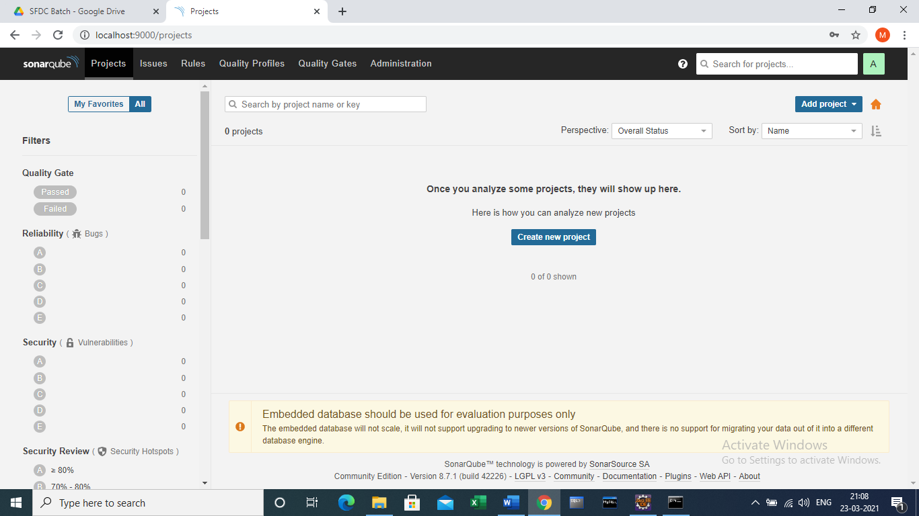

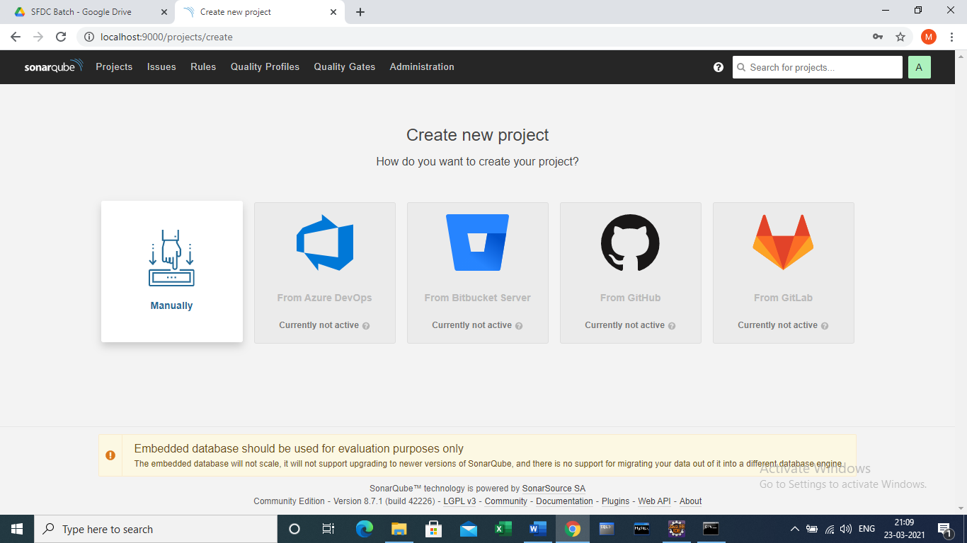

Select Manually Image

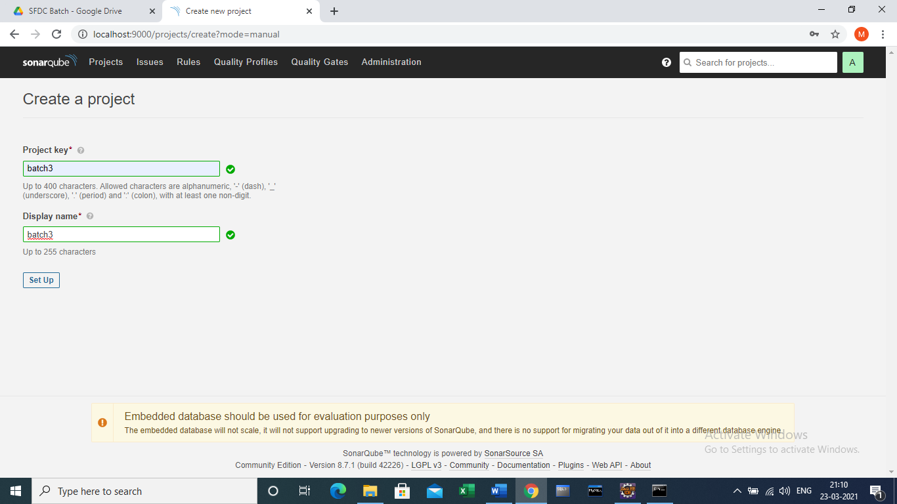

Enter project key and display name

Click ‘Set Up’

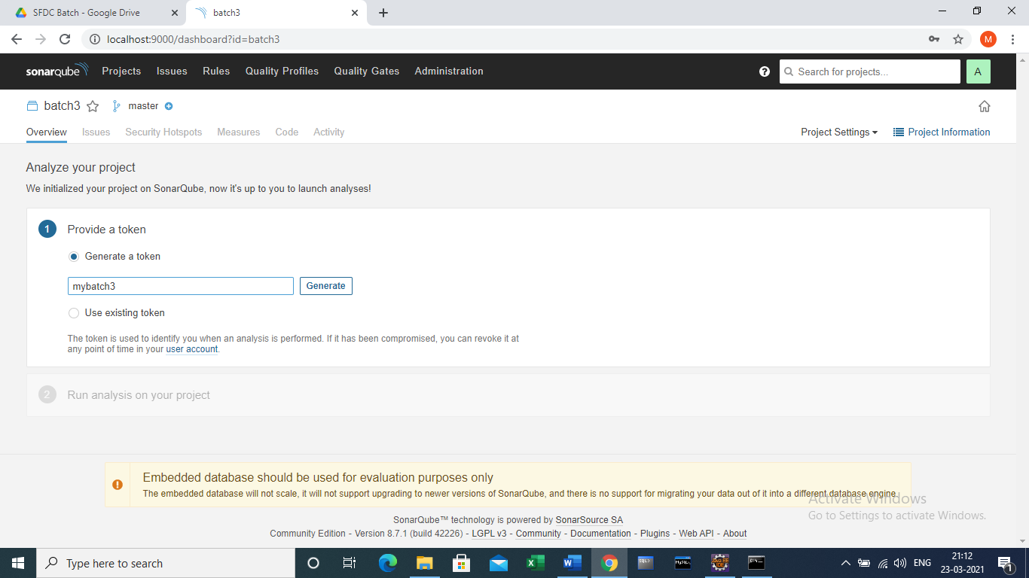

Enter name for a token

Click ‘Generate’

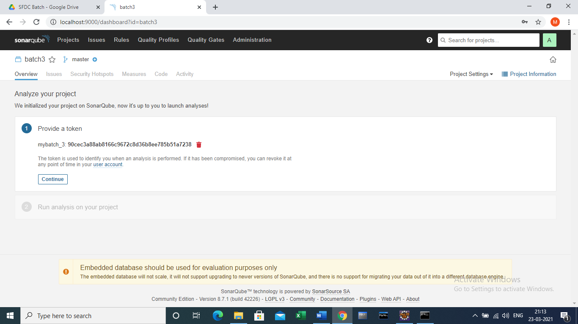

Click ‘Continue’

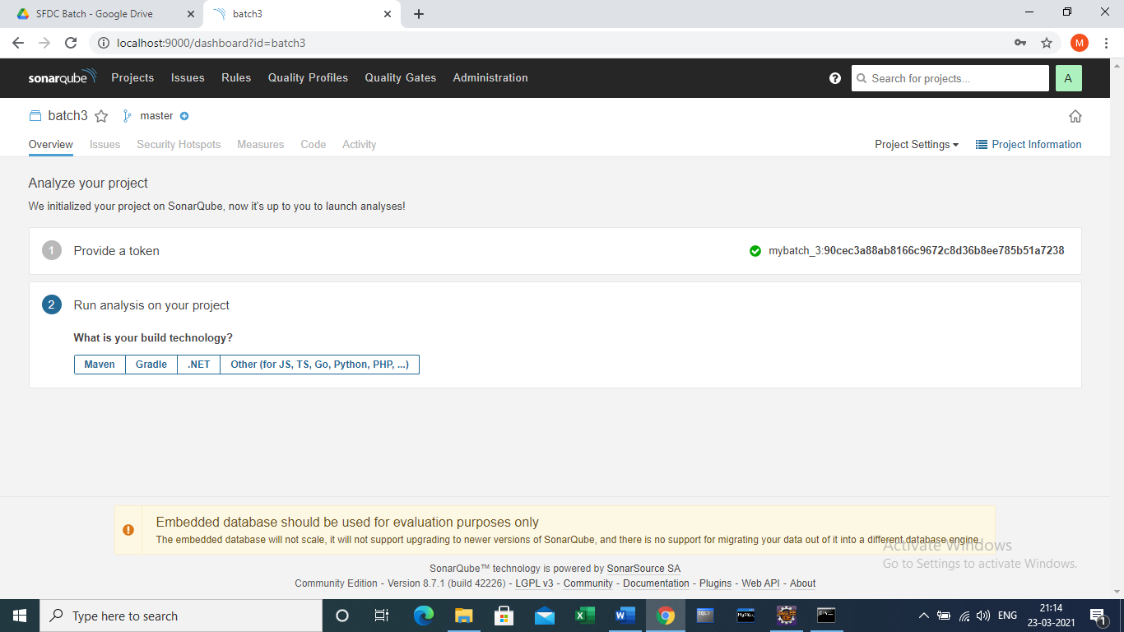

Click on ‘Maven’ tab button

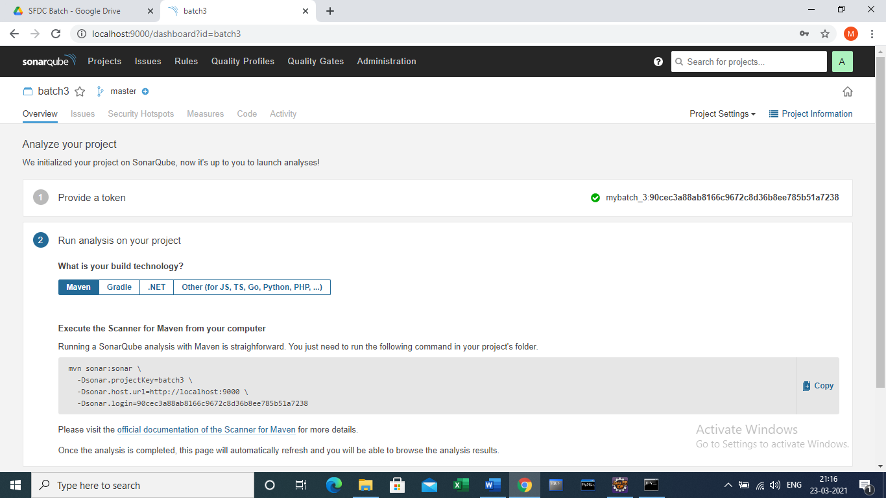

Click on ‘Copy’ button on following maven command

mvn sonar:sonar \

-Dsonar.projectKey=batch3 \

-Dsonar.host.url=http://localhost:9000 \

-Dsonar.login=90cec3a88ab8166c9672c8d36b8ee785b51a7238

Copy above command in notepad and arrange in one line. Remove mvn command. Remove character \

sonar:sonar -Dsonar.projectKey=batch3 -Dsonar.host.url=http://localhost:9000 -Dsonar.login=90cec3a88ab8166c9672c8d36b8ee785b51a7238

Copy above command and in eclipse maven project as follows

Right click on project -🡪 Run As 🡪 Run Configuration

Paste above command as maven goal

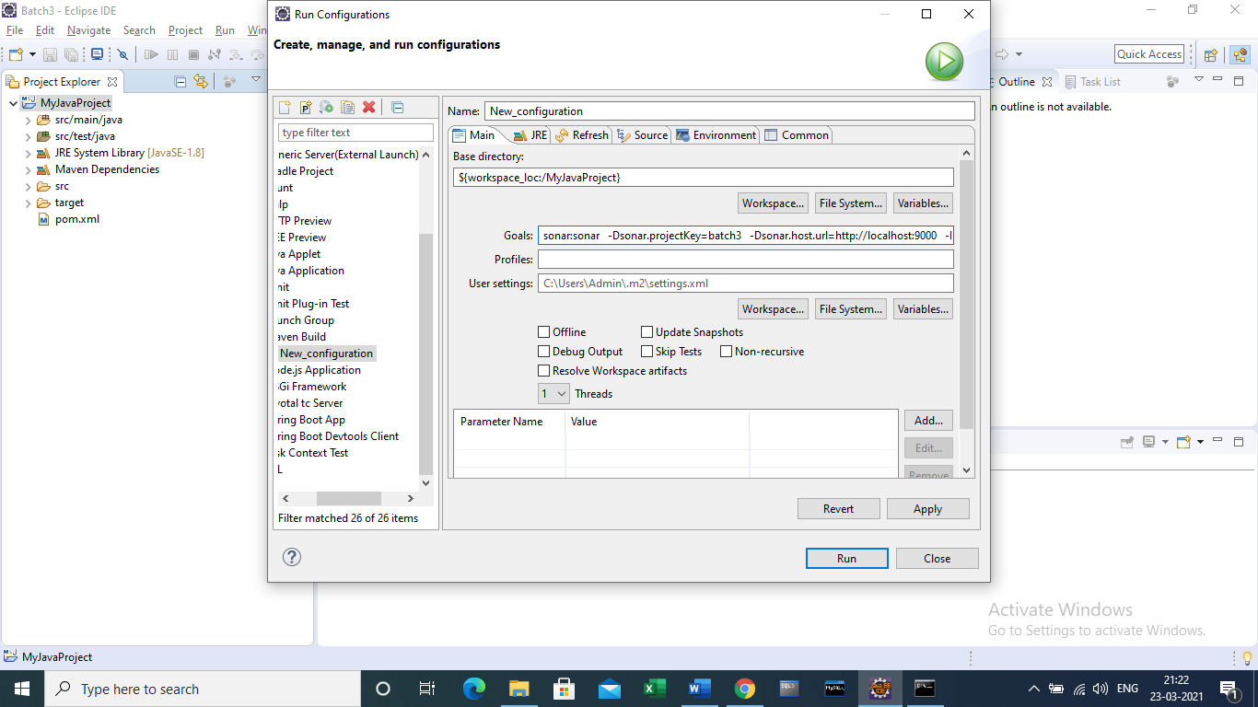

Click ‘Run’

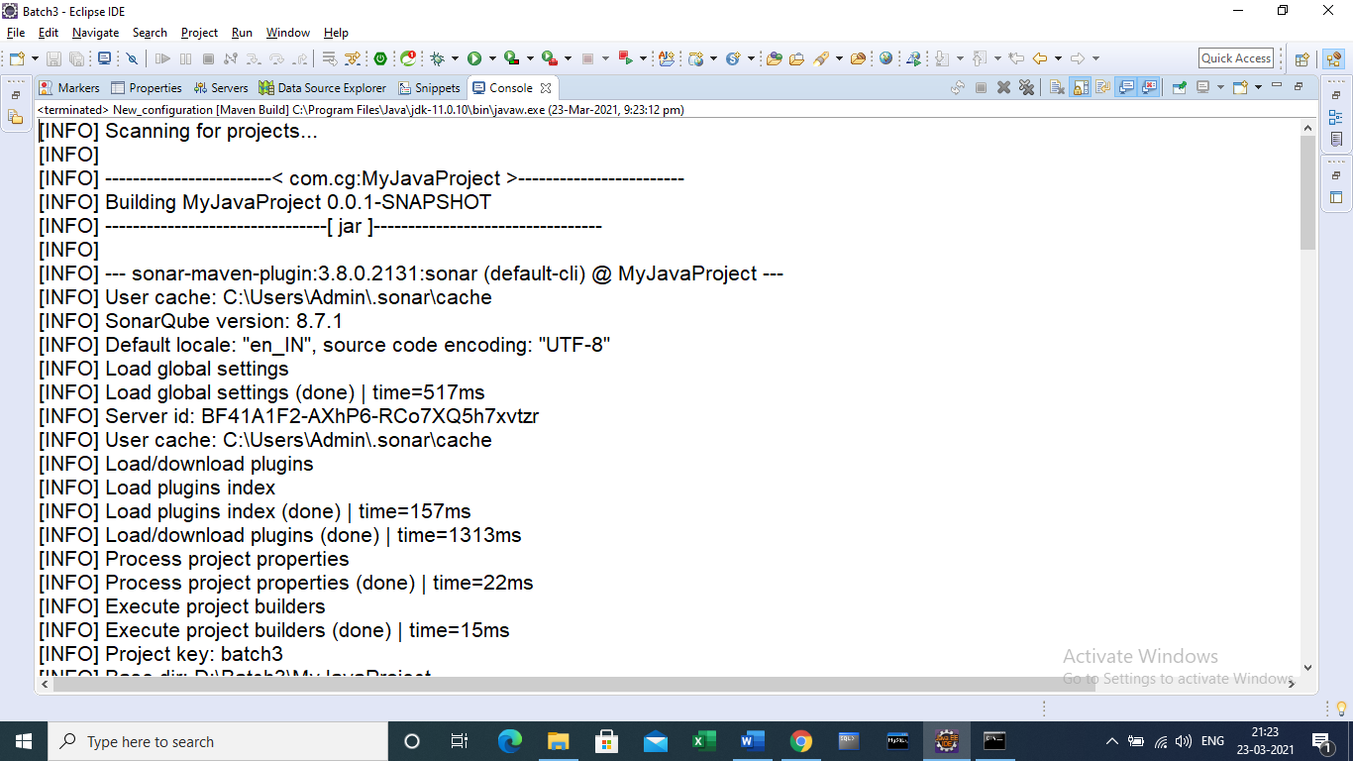

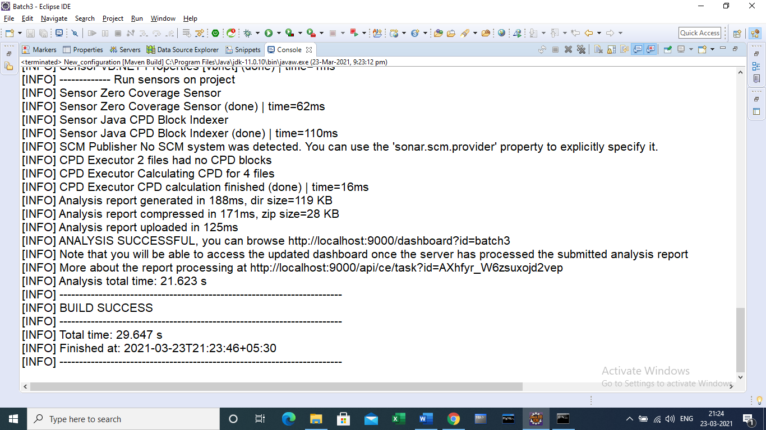

After this the whole analysis will come to the SonarQube server as follows

